SIMATS ENGINEERING (SAVEETHA SCHOOL OF ENGINEERING)
Department of Computer Science and Engineering

ASSESSMENT TOOL 2 – CASE STUDY

Course Code: | CSA06 | Course Title: | Design and Analysis of Algorithms
CO Assessed: | CO3: Articulation (BL4, BL5) | Assessment: | Assessment Tool 2 – Case Study
Weightage: | 20% of CIA | Total Marks: | 100
CO3 Statement: | Design Divide and Conquer algorithms for Merge Sort, Quick Sort, Binary Search and Matrix Multiplication
Student Name: | V SANJANA | Reg. No.: | 192571005
Section / Batch: | 2025 | Date: | 11-08-2026

Instructions to Students
- Answer the following question. Total Marks: 100.
- Carefully analyze the given case study questions.
- Explain in detail with sample code if needed.
- Clearly identify all key issues, provide an in-depth analysis, and propose innovative, feasible solutions with strong justification.

Question Type | Focus Area | Questions
Case Study | Focus on Design Divide and Conquer algorithms: Merge Sort, Quick Sort, Binary Search and Matrix Multiplication | Q1

SECTION A – CASE STUDY

Code of Conduct
I _V SANJANA(192571005)__ (Name / Reg No) certify that this submission is my original work and that I have adhered to the guidelines specified for this assessment. I understand that any violation of academic integrity rules will result in disciplinary action.
Signature of the Student: _________________________

RUBRICS FOR CALCULATION

 |  | Case Study
Criteria | Weightage | Level 4 –  Exemplary | Level 3 –  Proficient | Level 2 –  Developing | Level 1 –  Beginning
Understanding of Case | 25% | Thorough understanding; clearly  identifies all key issues | Good understanding with most issues identified | Basic understanding;  some issues missed | Poor understanding;  problem not  identified correctly
Application of Concepts | 25% | Effectively applies relevant concepts to  analyze the case deeply | Applies appropriate  concepts with minor gaps | Limited application of concepts | Fails to apply relevant concepts
Analysis | 20% | In-depth analysis with strong  reasoning and insights | Good analysis with logical reasoning | Basic analysis with limited depth | Weak or no analysis; lacks reasoning
Solution Design | 20% | Innovative, feasible  solutions with strong justification | Logical solutions with adequate justification | Basic solutions with weak  justification | Incorrect or no solution provided
Clarity | 10% | Clear, wellstructured, and easy to understand | Organized and understandable presentation | Limited clarity and structure | Poor clarity; difficult to understand

Marks Evaluation:
Criteria | Wt. | Level 4 –  Exemplary | Level 3 –  Proficient | Level 2 –  Developing | Level 1 –  Beginning
Understanding of Case | 25%
Application of Concepts | 25%
Analysis | 20%
Solution Design | 20%
Clarity | 10%
Total Marks (100):

Faculty In-charge | Course Coordinator | Head of Department
Name: | Name: | Name:
Signature: _______________ | Signature: _______________ | Signature: _______________
Date: ___________________ | Date: ___________________ | Date: ___________________

QUESTION:
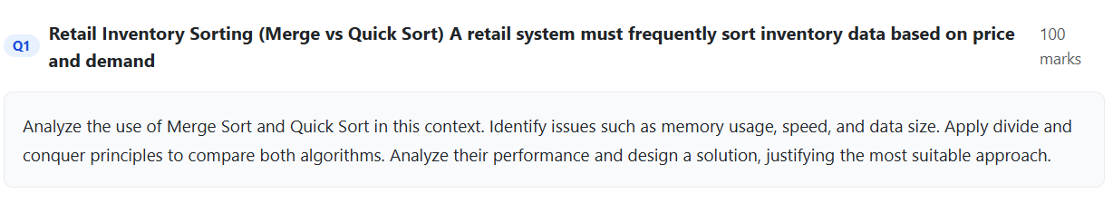

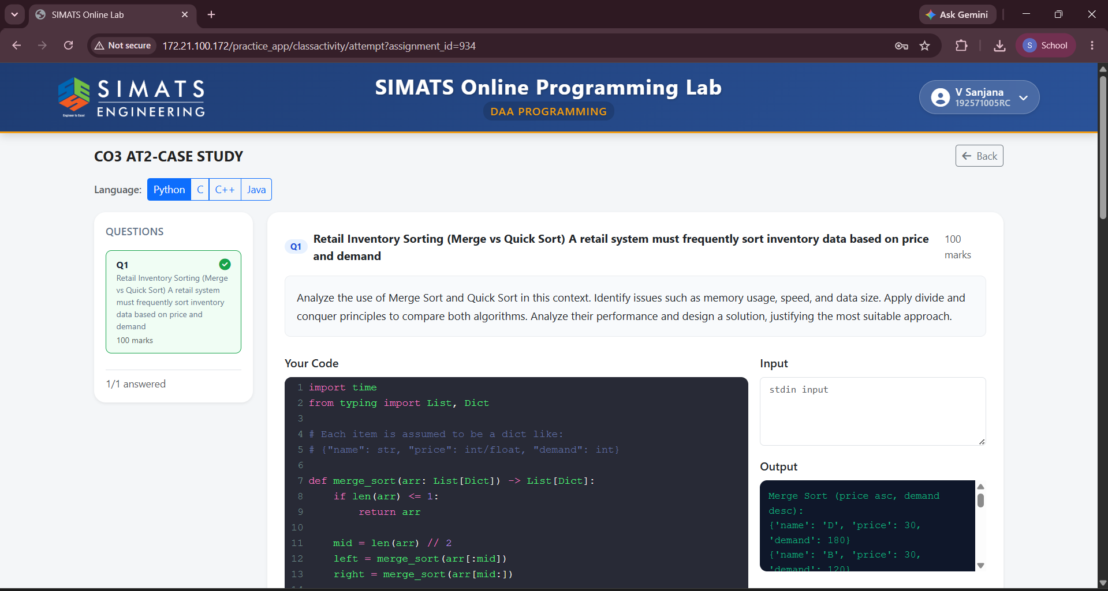

Merge Sort and Quick Sort are two important divide-and-conquer sorting algorithms that can be used in a retail inventory system to arrange products based on price, demand, stock quantity, or product ID. In a retail environment, sorting is performed frequently to identify low-priced products, high-demand items, fast-moving stock, and products that require restocking. Therefore, the sorting algorithm should provide good speed, efficient memory usage, and reliable performance even when the inventory contains a large number of records.
Merge Sort works by dividing the complete inventory dataset into two equal halves. Each half is further divided until individual elements are obtained. These smaller parts are then sorted and merged together in the correct order. The major advantage of Merge Sort is that its time complexity remains O(n log n) in the best, average, and worst cases. Hence, its performance is predictable even when the size of the inventory becomes very large. Merge Sort is also a stable sorting algorithm, which means that products with the same price or demand value maintain their original relative order. This is useful when the inventory is sorted using multiple attributes. However, Merge Sort requires additional memory of O(n) for storing temporary arrays during the merging process.

Time and Space Complexity
Case | Time Complexity
Best Case | O(n log n)
Average Case | O(n log n)
Worst Case | O(n log n)
Space Complexity | O(n)

Algorithm – Merge Sort
MERGE_SORT(A, low, high)
1. If low < high
2. mid = (low + high) / 2
3. MERGE_SORT(A, low, mid)
4. MERGE_SORT(A, mid+1, high)
5. MERGE(A, low, mid, high)

